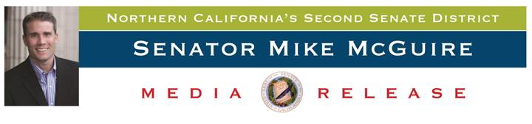

**For Immediate Release:** July 7, 2015

**Contact:** Kerrie Lindecker, [Kerrie.Lindecker@sen.ca.gov](mailto:Kerrie.Lindecker@sen.ca.gov) or (707) 319-3654

**The Time is Now: Senator McGuire’s Medical Marijuana regulation bill pushes forward with approval from Assembly committee**

***SB 643 provides necessary framework for un-regulated medical marijuana industry***

***Sacramento, CA***– Senator Mike McGuire’s bill to bring much-needed, and desired, regulation to the medical marijuana industry was again approved by another committee this week as it makes its way through the legislative process. SB 643 – The Medical Marijuana Public Safety and Environmental Protection Act – received overwhelming support in the Assembly Business & Professions Committee Tuesday morning gaining even more momentum as the bill has already cleared three Senate committees, as well as passing on the Senate floor in June.

**“The time is now. Our environment and our communities are paying the price for the state’s lack of action over the past 20 years,” said Senator Mike McGuire (D-Healdsburg). “This legislation will advance sweeping regulations and desperately needed resources that are necessary to address the impacts of this multi-billion dollar industry.”**

Last week, Senator McGuire, as Chair of the Joint Committee on Fisheries and Aquaculture, led a hearing addressing the impacts of rogue marijuana grows on the state’s fisheries. From water officials, fishery experts and state agency leaders to law enforcement and cannabis growers, it is clear that large-scale rogue marijuana grows are having a negative impact on Northern California watersheds.

**“The impacts are horrendous and the drought has had an exacerbating effect, especially on the North Coast. Entire rivers are running dry as marijuana grows expand and the fourth year of this historic drought sets in,” McGuire said.**

Rogue operators have cut down tens of thousands of acres of Northern California forests illegally without regard for the environment, neighboring communities, downstream farms, or endangered species. In addition, tens of thousands of pounds of pesticides, rodenticides and fertilizers have been dumped into watersheds that flow through Northern California communities. Rogue marijuana grows are the number one source of sediment and nutrient load in Northern California rivers.

On the North Coast, many of the medical cannabis growers are managing small family farm operations and are eager to comply with potential new regulations. These farmers have worked the land, in many cases, for decades and are seeking a balanced approach. SB 643 would provide a legal framework for those farmers who are working with Senator McGuire on this important legislation.

Senator McGuire’s bill, SB 643, provides a regulatory framework for the industry covering the issues of environmental protection and water regulations, law enforcement, licensing, public health related to edibles and product testing, to marketing, labeling, taxing, transporting, zoning, local control and re-sale (and more). This bill is only focused on Medical Marijuana and does nothing to legalize the recreational use of marijuana.

###